

### [Final Report Submission](https://cites.openlearn.lk/mod/assign/view.php?id=7432)

**For**

**Cloud 4 Travel Website**

**Cluster : 3.1**

**Mentor : Ms.ahalikai suthaharan**

**Our group members**

**M.A.C.M.Sumail – s92068923**

**I.N.Jahan – s92068909**

**A.Afni Ahamed – s92075238**

**M.Y.Azeez Ahamed – s92077064**

**Content**

1. **Introduction** Background of the project
2. **Problem statement & Project Objectives**
3. **Introduction to similar type of Systems**
4. **Project Solution**
5. Technology used - backend (ex. database design tools)/ Frontend (ex. UI Design tools)
6. Design document

* Use case diagram
* class diagram
* activity diagram
* ER diagram
* Test case
* Overall architecture-block diagram

1. **Test Case Document and Test results**
2. Conclusion
3. Project Demonstration
4. Appendix

**updated SRS,** [Monthly Retrospective](https://cites.openlearn.lk/mod/url/view.php?id=9188)**, Evidence for the use of Project governance tool & GIT account, CMMI meeting minutes**

**INTRODUCTION**

* This report's goal is to give a thorough explanation of Sri Lanka's tourism management system. It will describe the background and characteristics of the system, its interfaces, design, development, test results.

**BACKGROUND OF THE PROJECT**

* The cloud4 Travel and Tourism website project was initiated in order to provide a comprehensive and user-friendly platform for individuals planning their next vacation or business trip. The target audience for the website includes leisure travelers, business travelers, and travel agents.
* The website will feature destination guides with detailed information on popular tourist destinations, including things to do, where to stay, and where to eat. Users will also be able to read reviews of hotels, restaurants, and other travel-related businesses, as well as book transport and hotels directly through the website.
* In addition, the website will offer a trip planning tool that will allow users to create personalized itineraries and share them with friends and family. The website will also include a travel blog, featuring articles written by travel experts and destination-specific information.
* To promote the website, a comprehensive digital marketing strategy will be implemented, including search engine optimization, social media marketing, and email marketing campaigns. The website will also be optimized for mobile devices, allowing users to access the site and plan their trips on the go.
* The goal of the cloud4 Travel and Tourism website project is to become the go-to resource for individuals planning their next travel adventure and make the process of planning a trip as seamless and enjoyable as possible.

**Problem Statement**

* The purpose of website is established fact that Internet users are increasing today.
* Today one of the main purposes of the website is to facilitate the offline customer online because customers cannot spend their precious time in markets trying to find out the best deal.
* Our priority will be our customers and their travel requirements.
* There will be many users visiting the portal and hence we require a strong and reliable frontend which can withhold the users on our site.
* We will be putting an effort to provide the right choice to the people when they plan a holiday and beware them from the false advertising

**Project Objectives**

* The objective of this presentation is to demonstrate the effectiveness of our new travel and tourism website as a one-stop-shop for travellers, by showcasing its intuitive design, comprehensive offerings, and advanced technology for easy and efficient trip planning and booking.

**Introduction to similar type of Systems**

**Project Solution**

**Technology used**

**Frontend Technology**

* Figma
* Html
* CSS
* Javascript

**Backend Technology**

* PHP
* XAMPP SEVER

**DESIGN**

USE CASE DIAGRAM

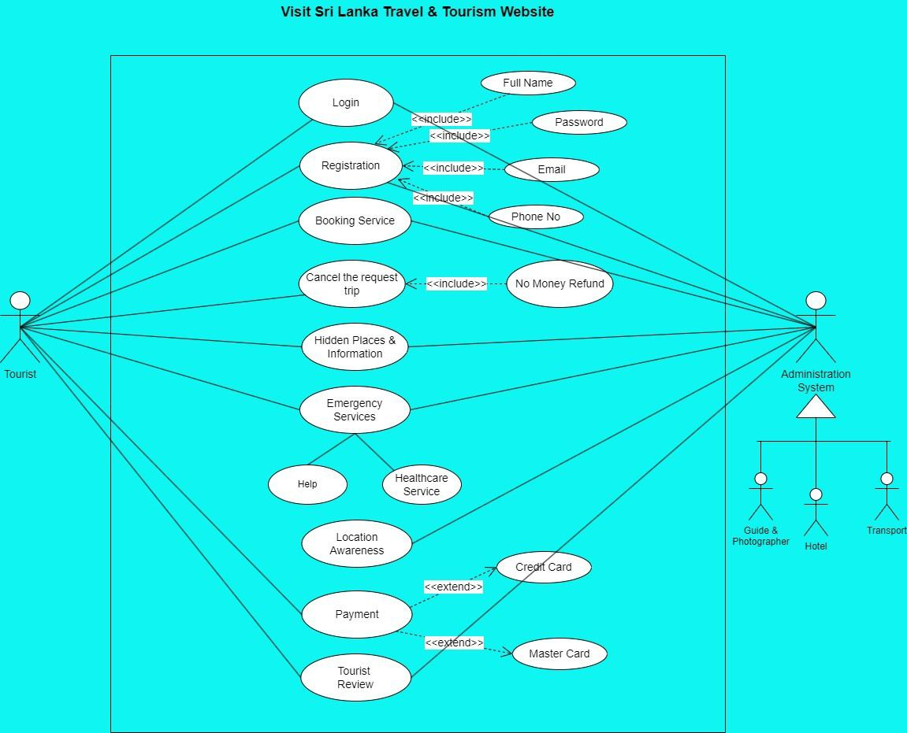

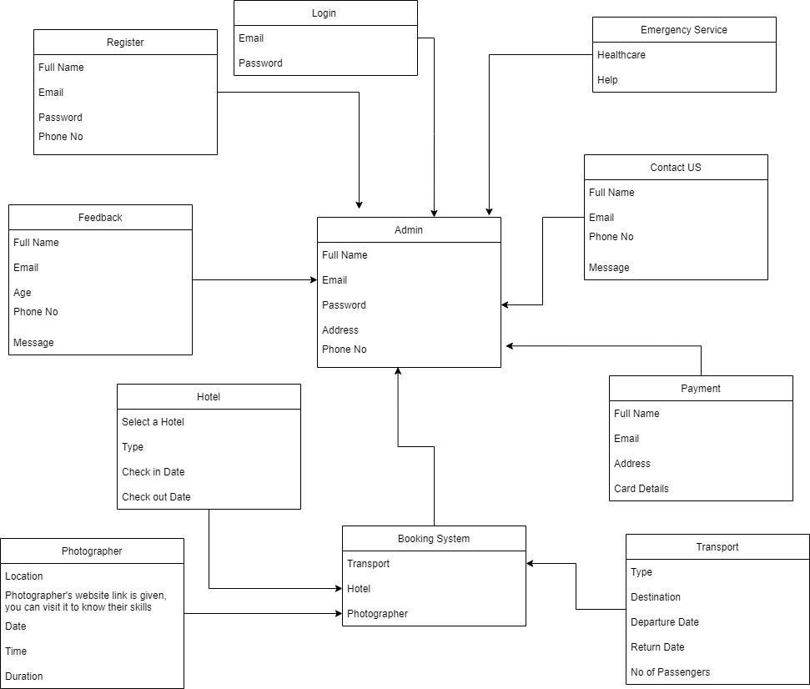

CLASS DIAGRAM

ACTIVITY DIAGRAM

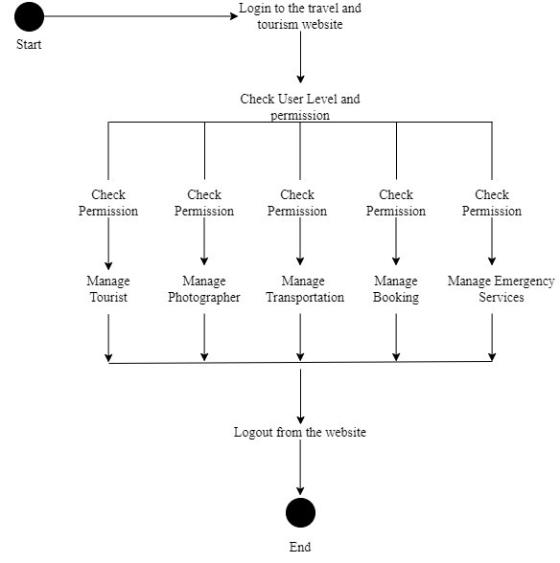

ER DIAGRAM

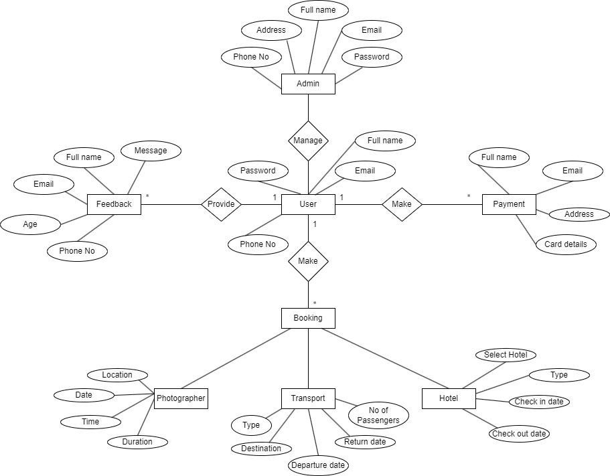

**OVERALL ARCHITECTURE-BLOCK DIAGRAM**

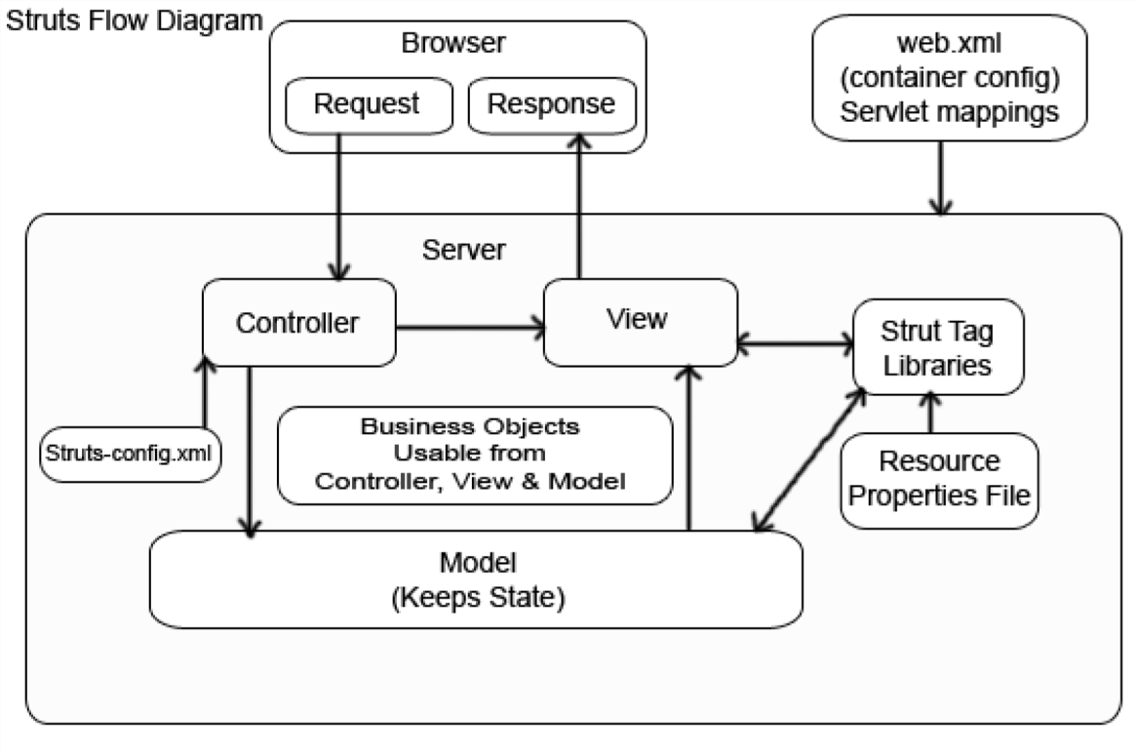

**TEST CASE DOCUMENTS**

* It is merely a list of chores that you keep track of for simpler tracking. A software test checklist outlines the tests you should conduct according to a certain process. You can determine all the tests you need to run, the number of successful and failed tests, and more by using a software test checklist.
* Test Case Document Google Drive Link: [https://docs.google.com/spreadsheets/d/1Gactd5x70aoChqcB4_4tFoC60KcBRn1m/edit?usp=share_link&ou id=102986765256943188125&rtpof=true&sd=true](https://docs.google.com/spreadsheets/d/1Gactd5x70aoChqcB4_4tFoC60KcBRn1m/edit?usp=share_link&ouid=102986765256943188125&rtpof=true&sd=true)

**OUTPUT OF THE SYSTEM**

**Home Page**

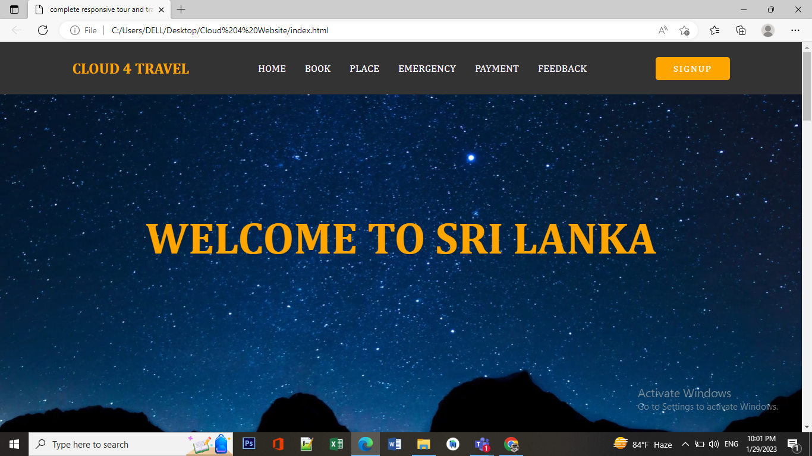

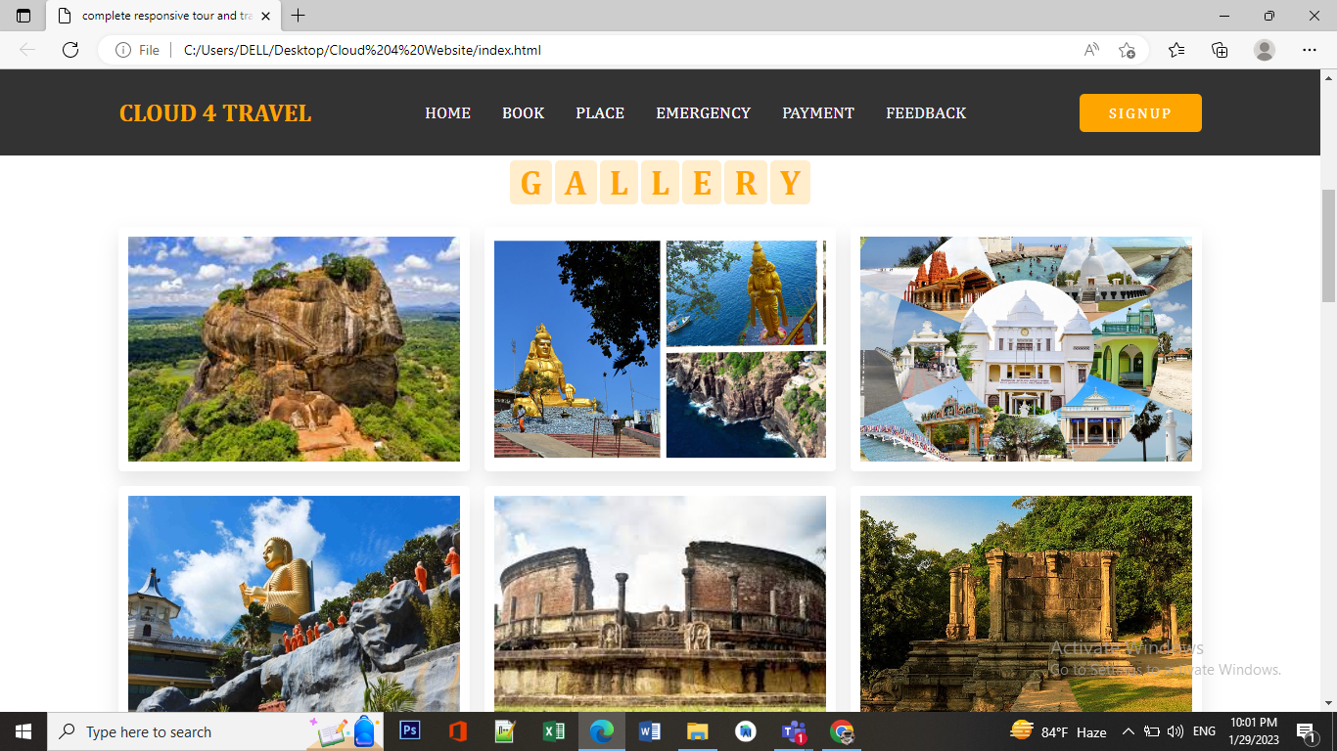

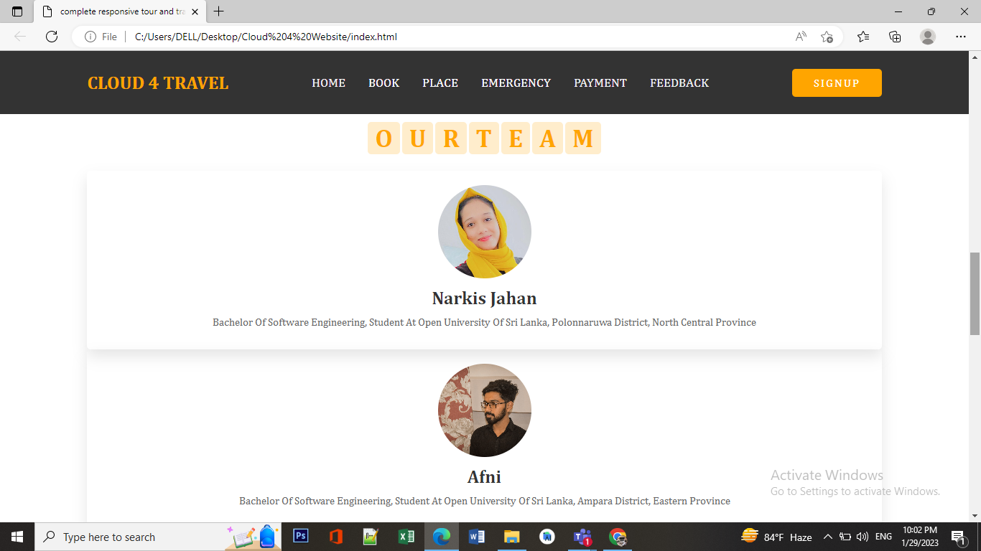

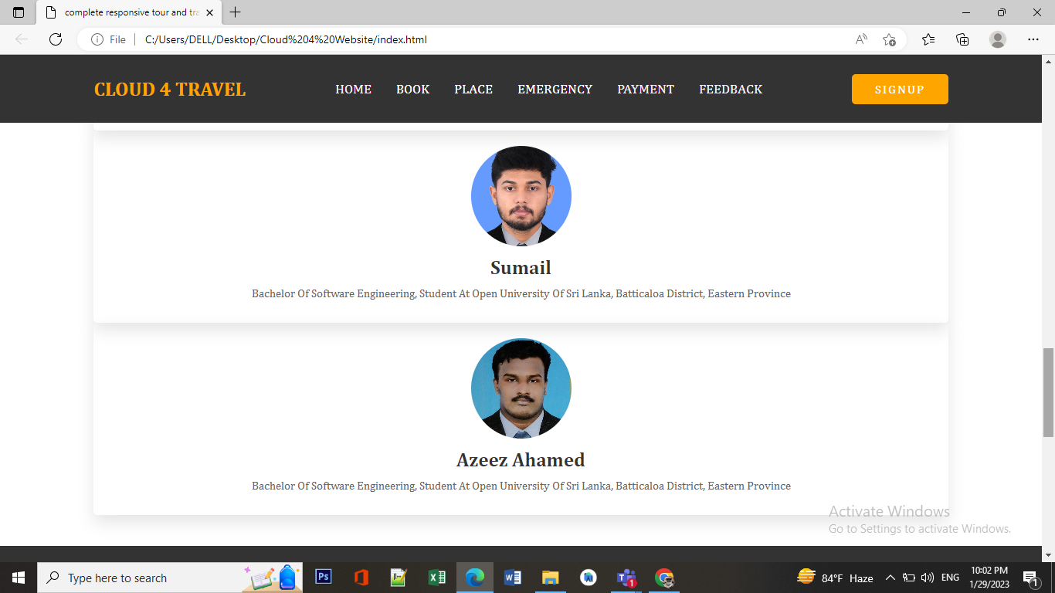

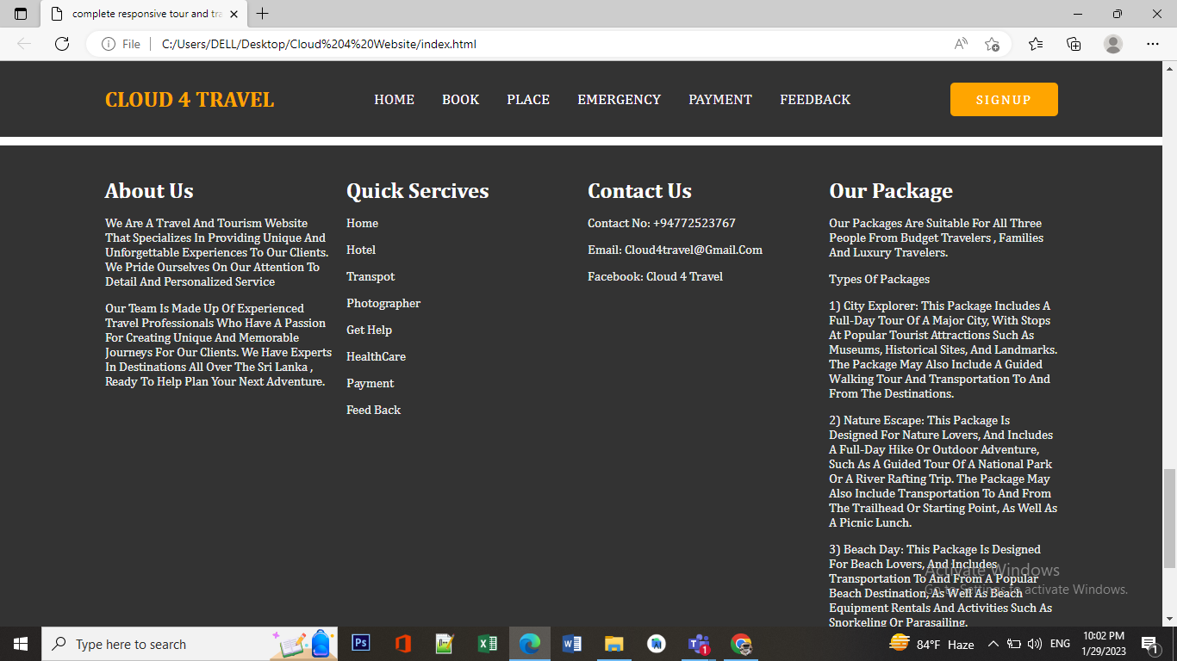

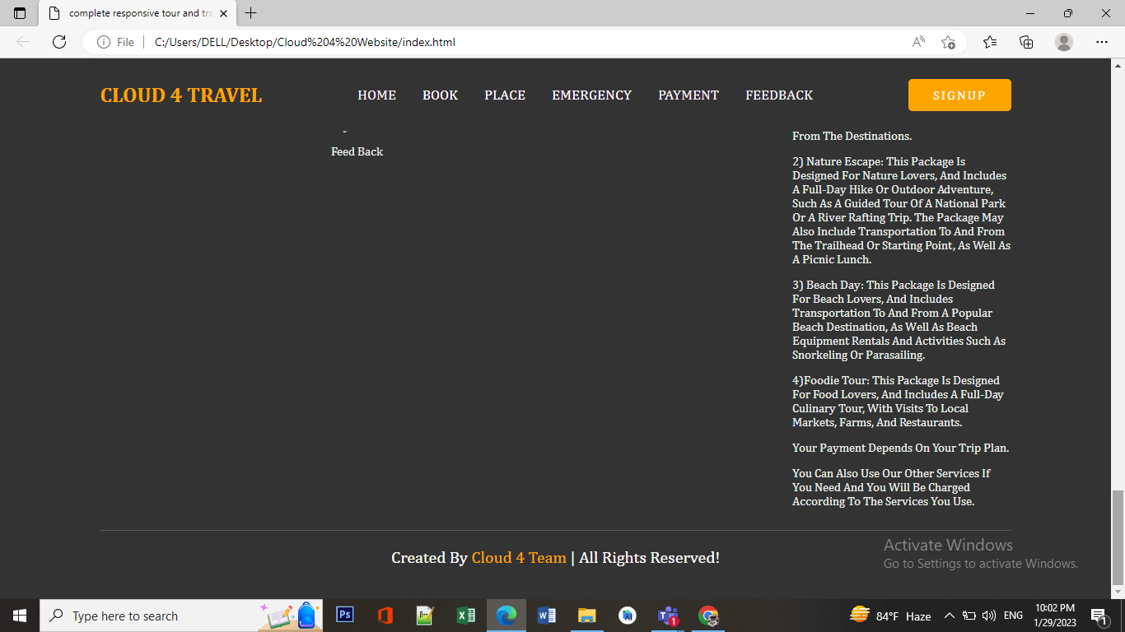

**Booking Page**

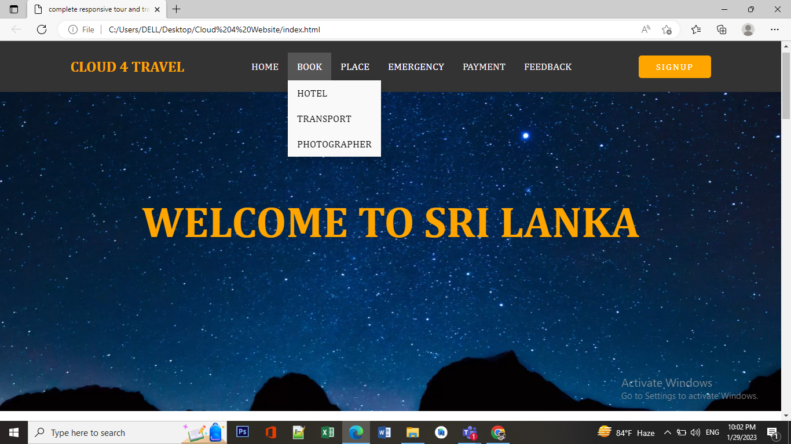

**Hotel Booking Page**

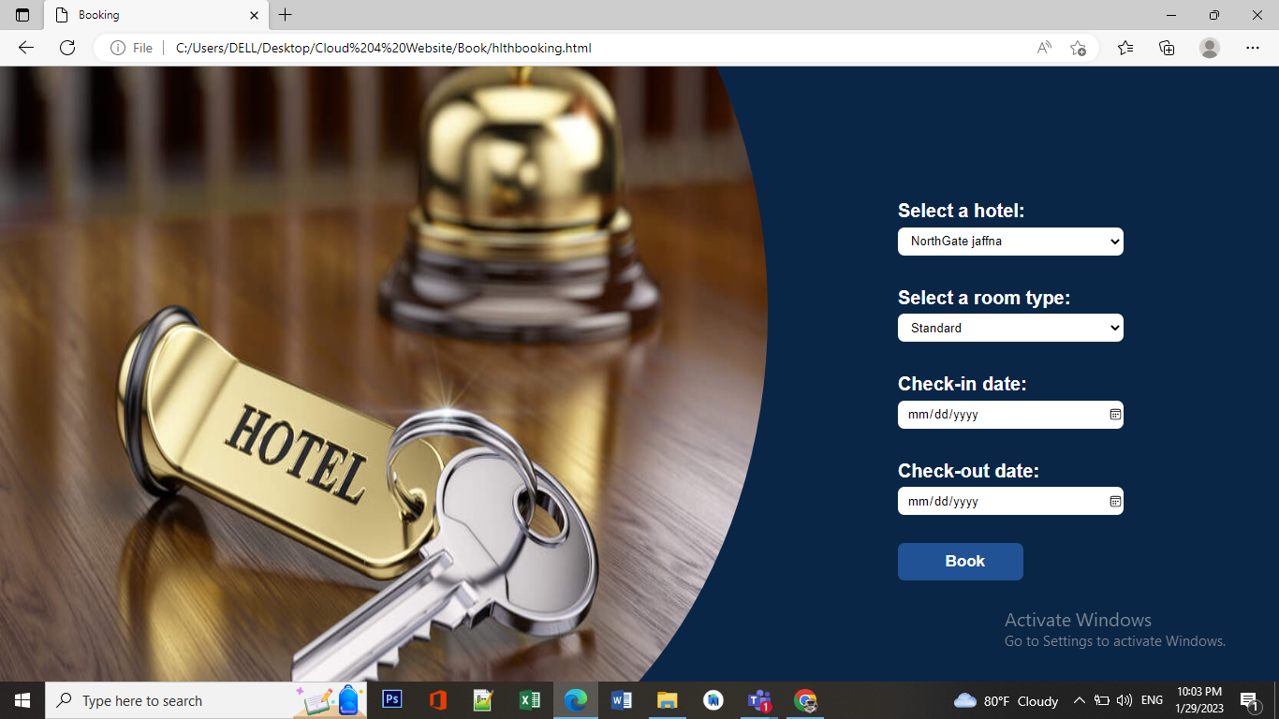

**Transportation Booking Page**

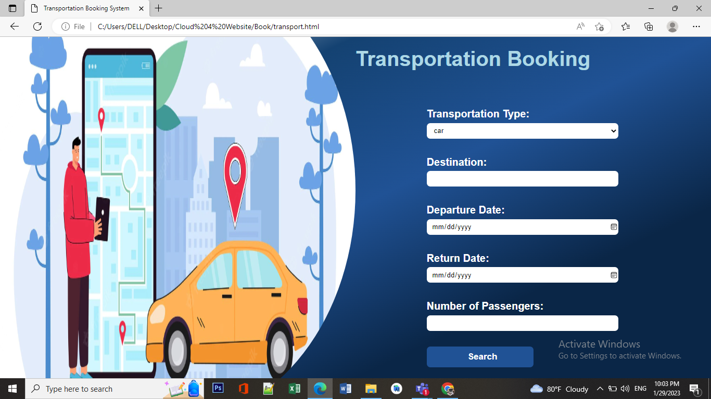

**Photographer Booking Page**

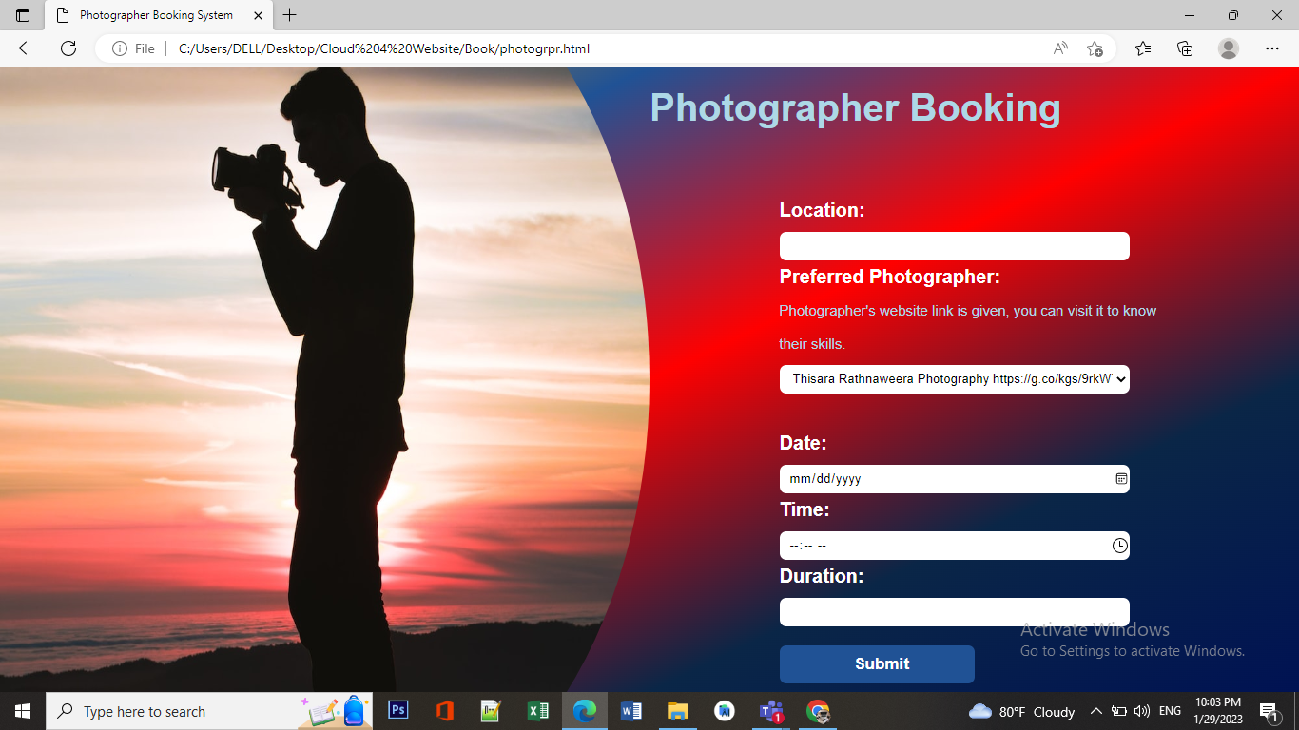

**Place Page**

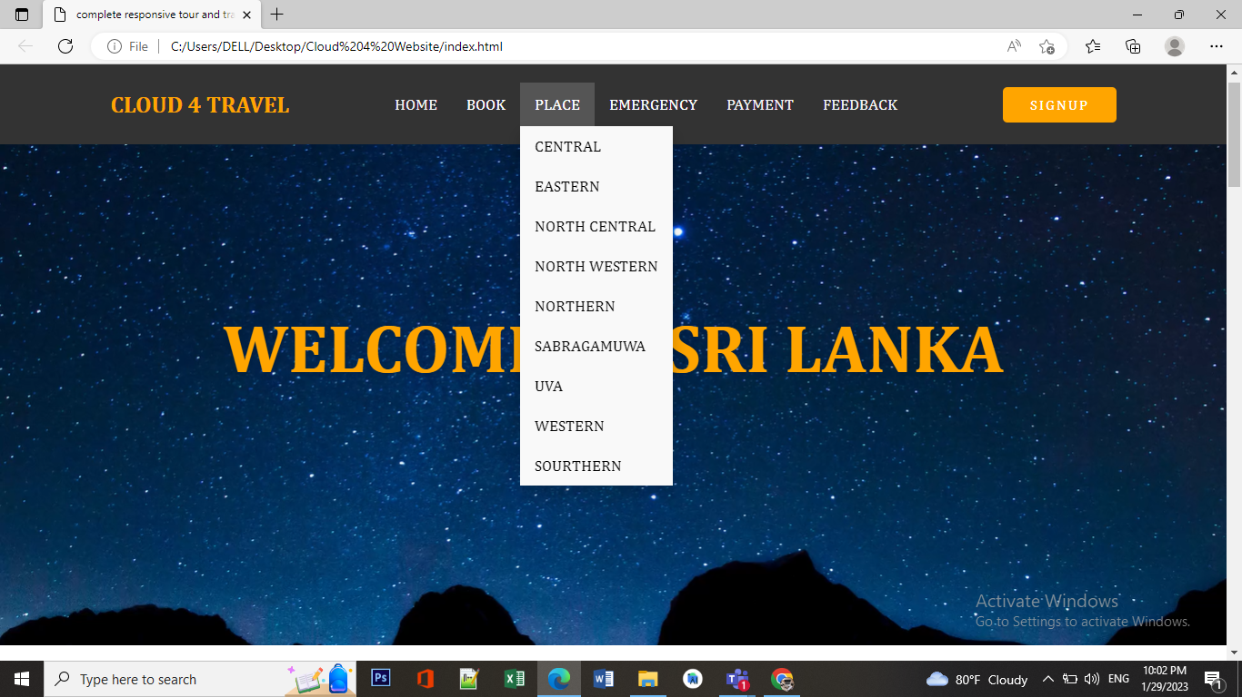

**Ex:**

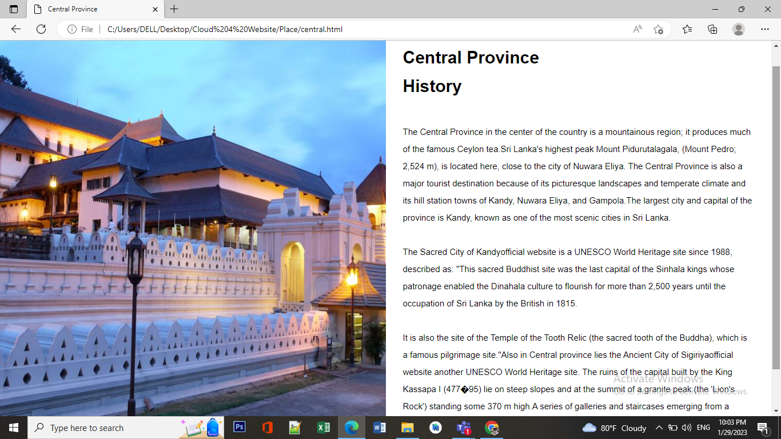

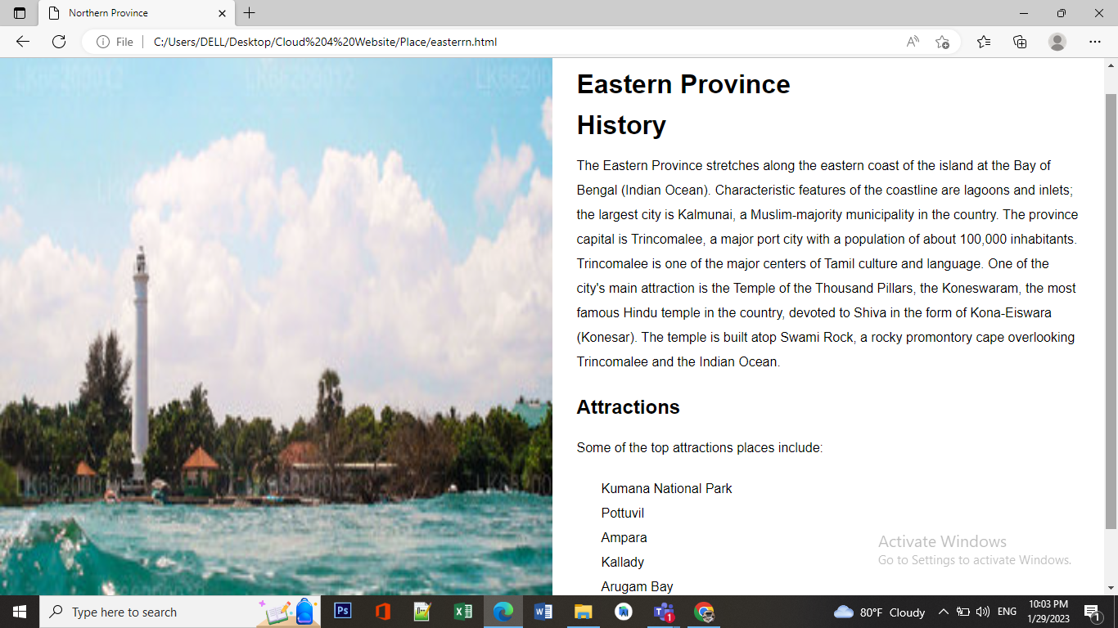

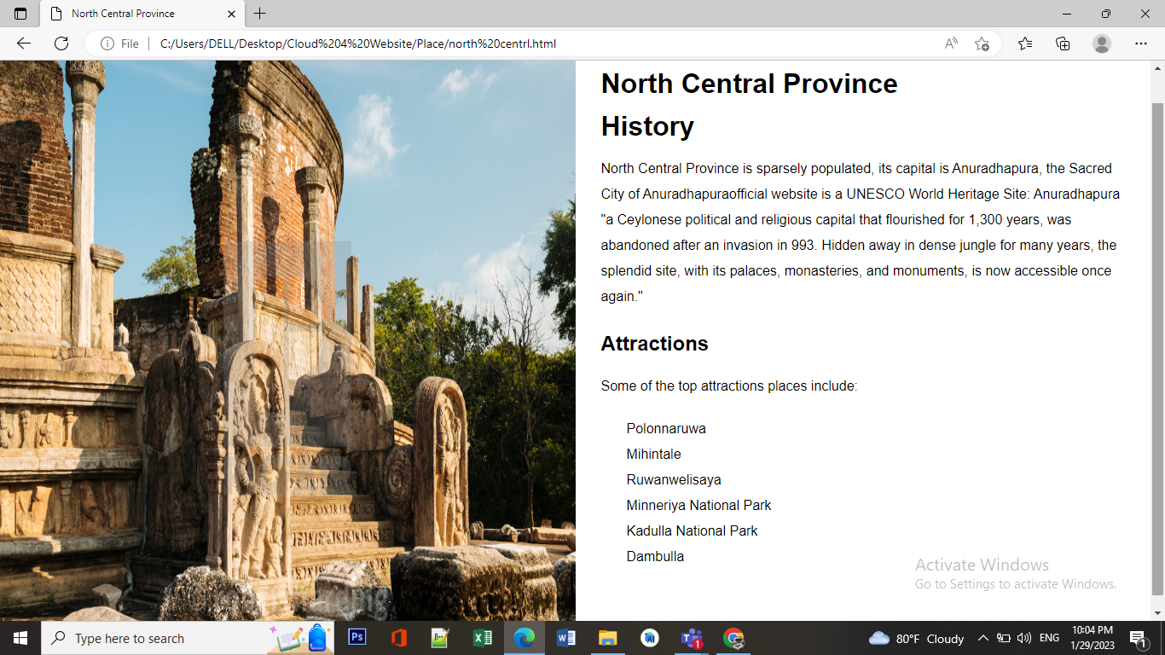

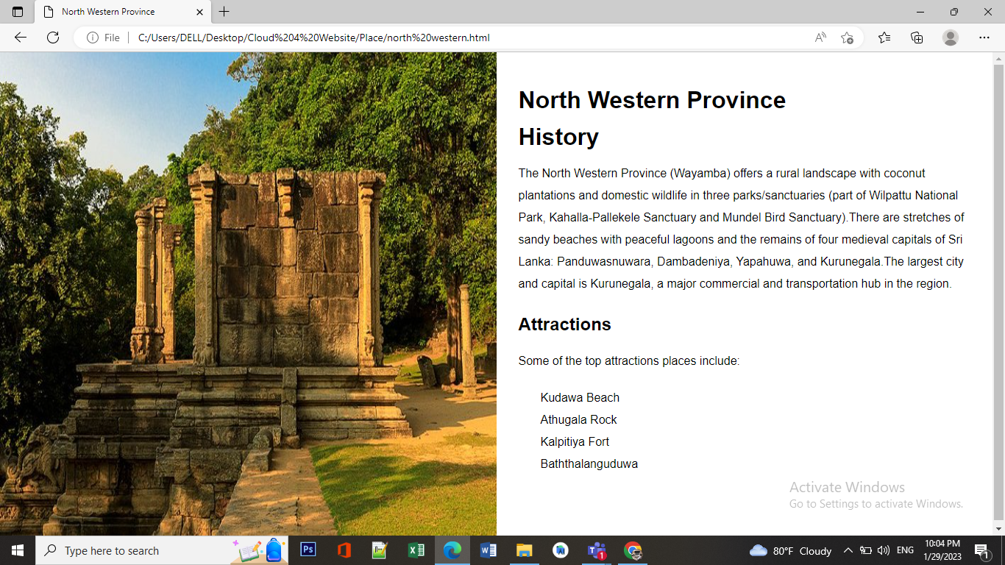

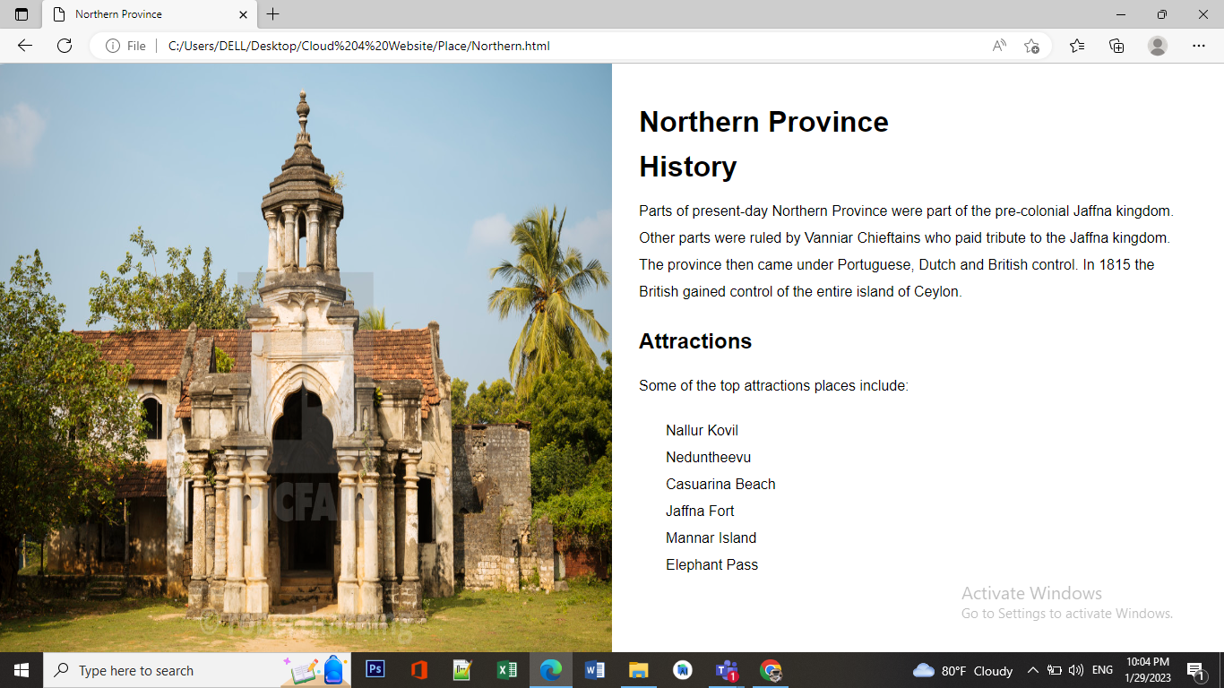

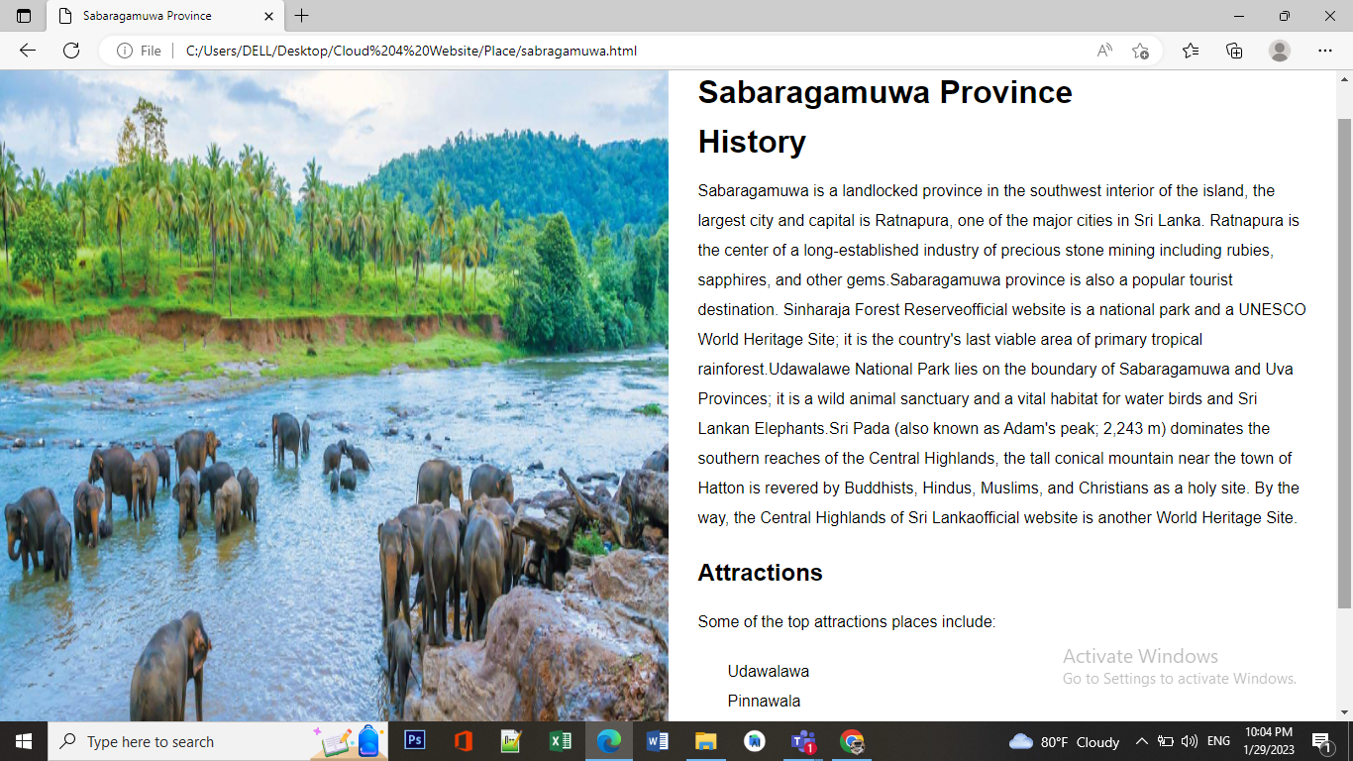





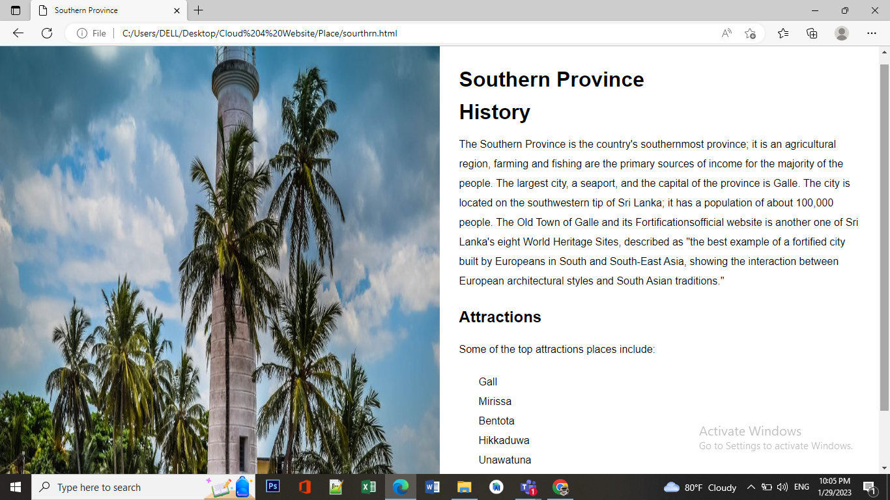

**Payment Page**

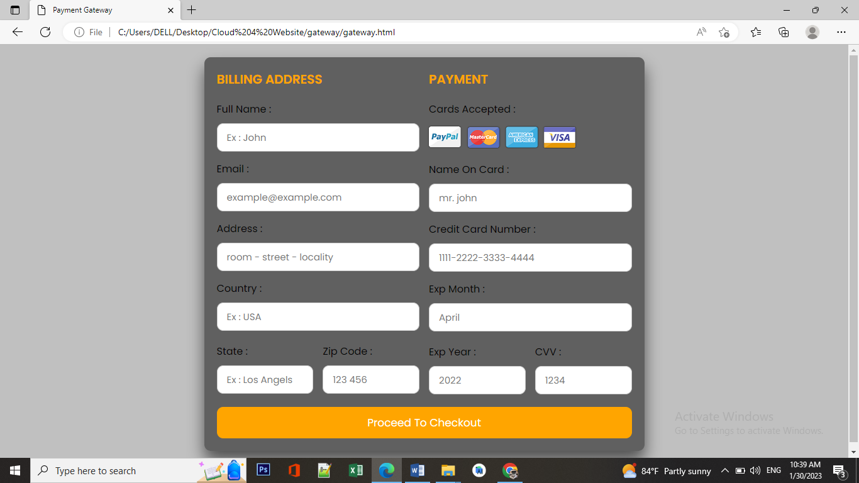

**Feedback Page**

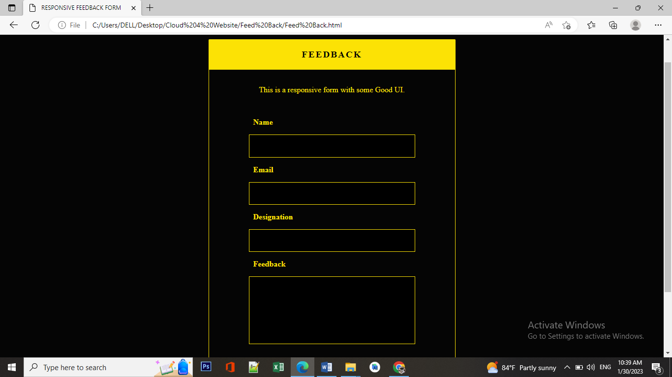

**Emergency Page**

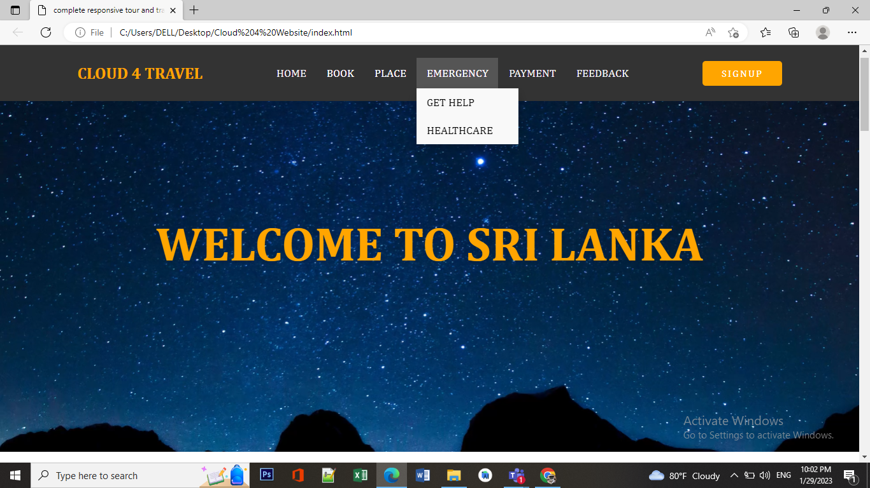

**Get Help Page**

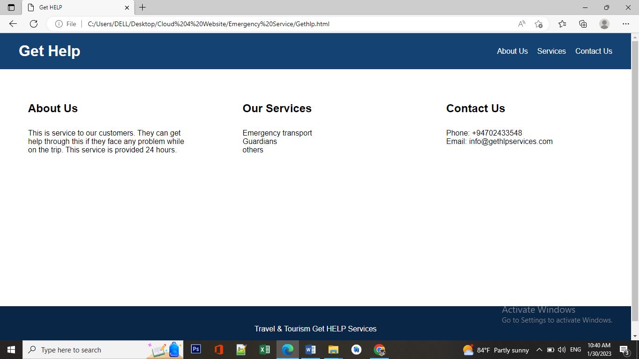

**Healthcare Page**

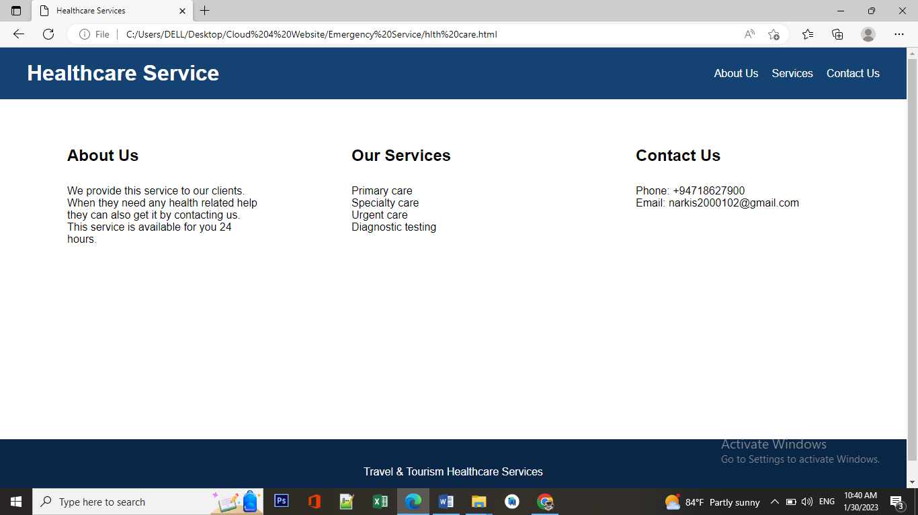

**Login Page**

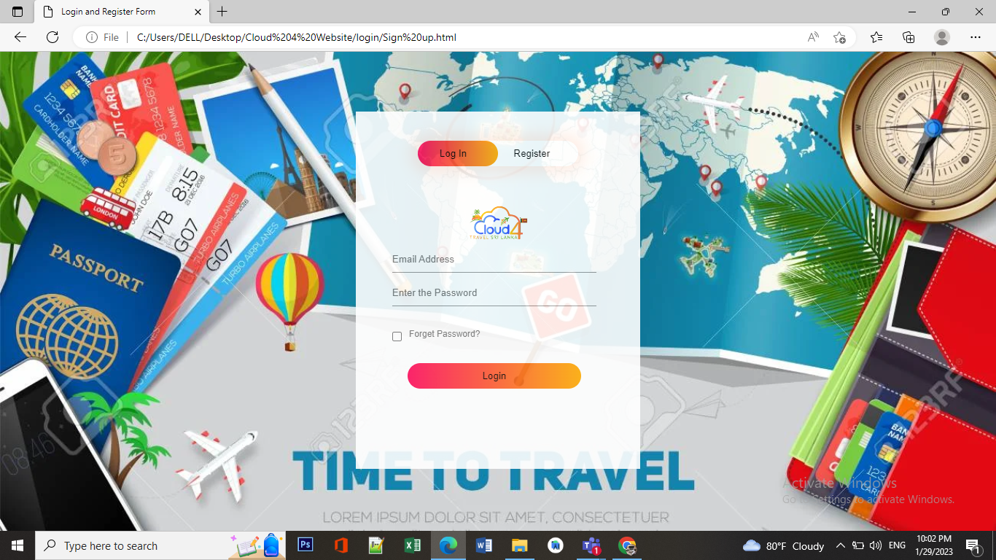

**Register Page**

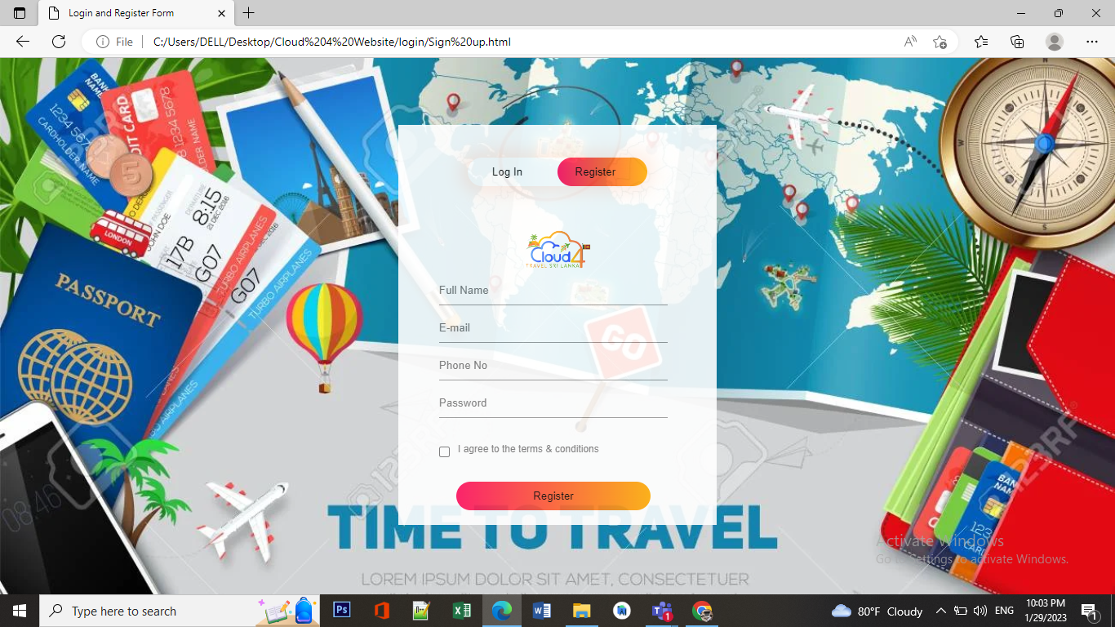

**TEST RESULT**

* **Methodology:** The testing was conducted using a combination of manual testing, automated testing and user feedback. The criteria used to evaluate the website included loading speed, ease of navigation, responsiveness, and the availability of information on destinations.
* **Results:** Overall, the website performed well in terms of fast loading speed and intuitive navigation. The website also provided a good range of information on destinations, including images and descriptions. However, some areas were identified as needing improvement, such as slow search function and limited information on transportation options. These findings are supported by relevant data and screenshots.

**APPANDIX**

* SRS Report’s google drive link : <https://drive.google.com/file/d/1DOneMLEP7sSniQcZXEz33pxxkX5I4_PR/view?usp=share_link>
* CMMI Meeting Link : <https://docs.google.com/spreadsheets/d/1BkIfpwvPnU47VEnQ5gvesmtR2FomZA2H/edit?usp=share_link&ouid=102986765256943188125&rtpof=true&sd=true>
* We have contacted task contributing for the project in the Github repository. Our mentor is a member of Github repository
* Github Link : <https://github.com/cloud4-cloud4>
* Log sheet link :

<https://docs.google.com/spreadsheets/d/1kdGAV3LqJv7FfN32xC2Ayay6e6PohRsWDceOIDnBjT0/edit?usp=share_link>

**REFLECTIVE JOURNAL**

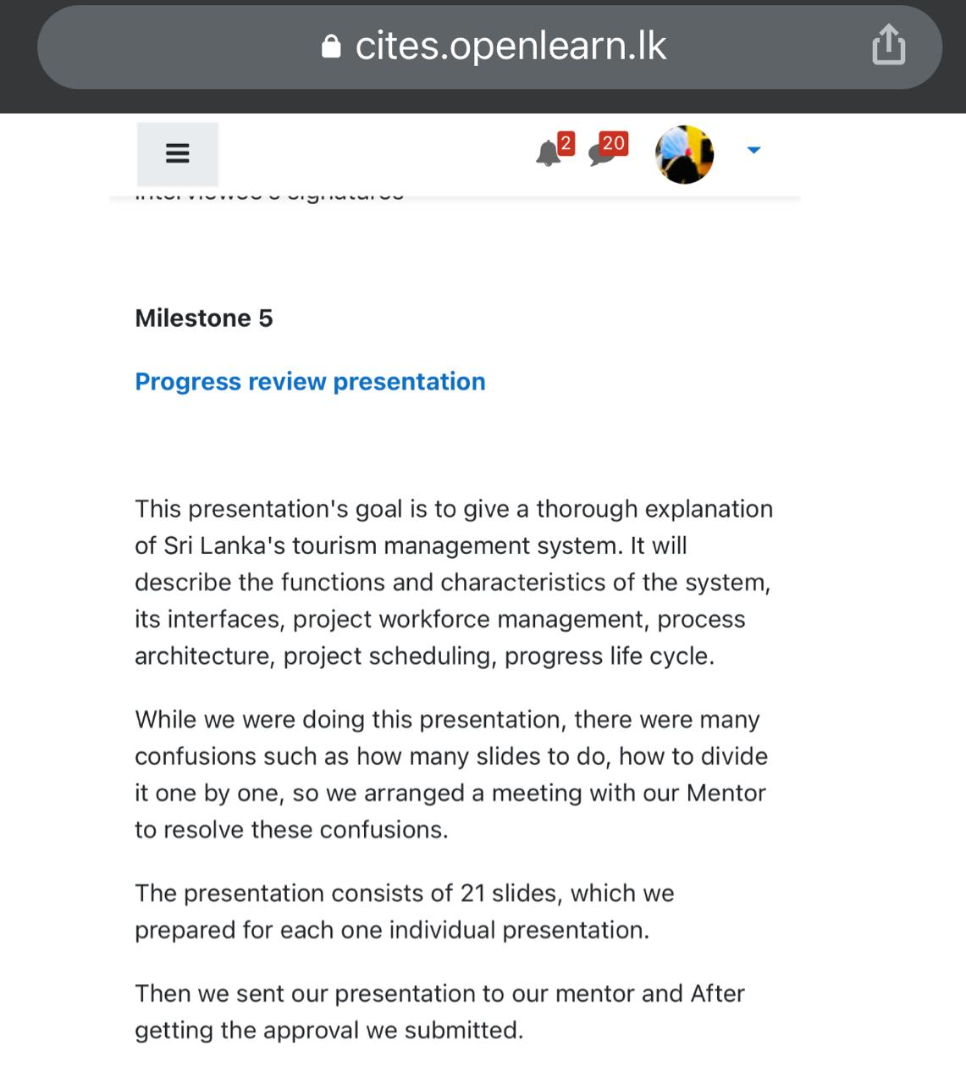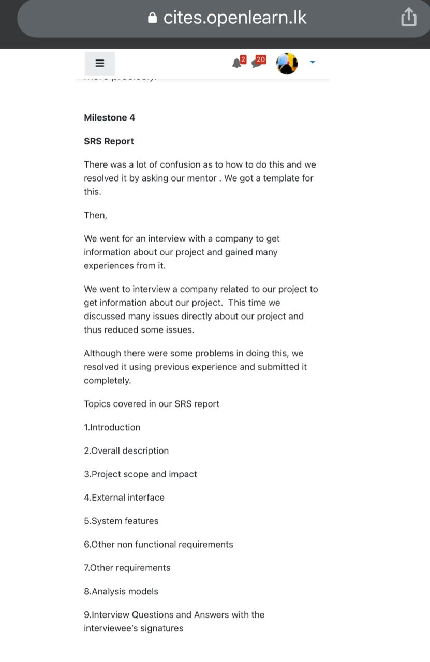

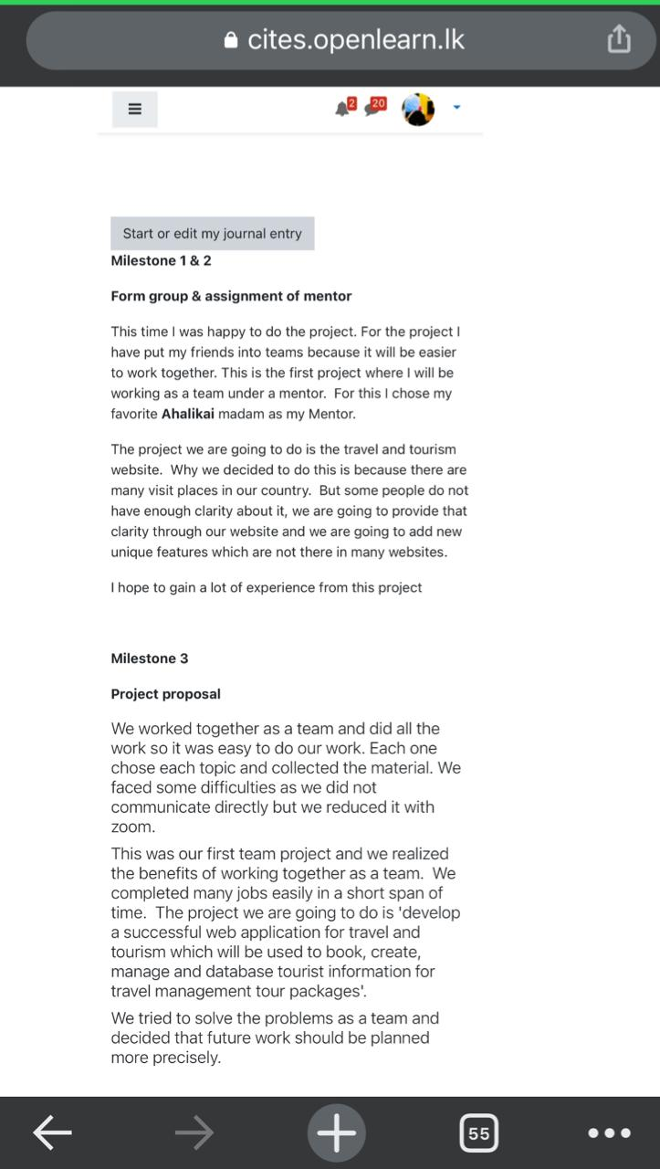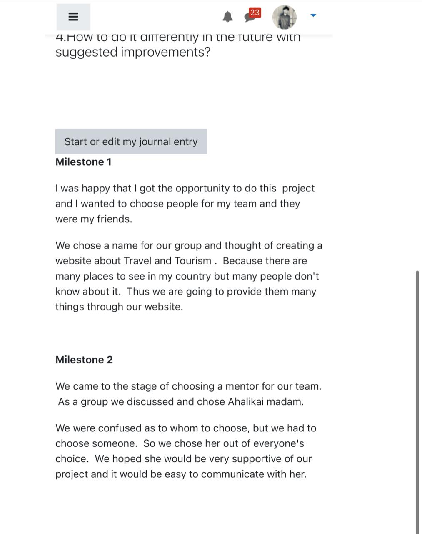

**CONCLUSION**

* This website was successfully developed and project has been appreciated by our mentor. Any endeavor is incomplete without the spirit of team work. We could not have completed this without our team.

* It was used to hold all the booking, creation, management, and tour information for travel administration tourism packages in the database. The software was thoroughly tested, and any flaws were correctly debugged. Additionally, testing revealed that the system's performance is sufficient. The entire required production has been produced. Thus, this system offers a simple method for automating all consumption-related tasks.
* The project can yet be improved, making the website run much more attractively and effectively than it does now. It may be said that the application meets the needs and functions well. The software is thoroughly tested, and any faults are properly debugged. It also serves as a means of exchanging files with important sites.